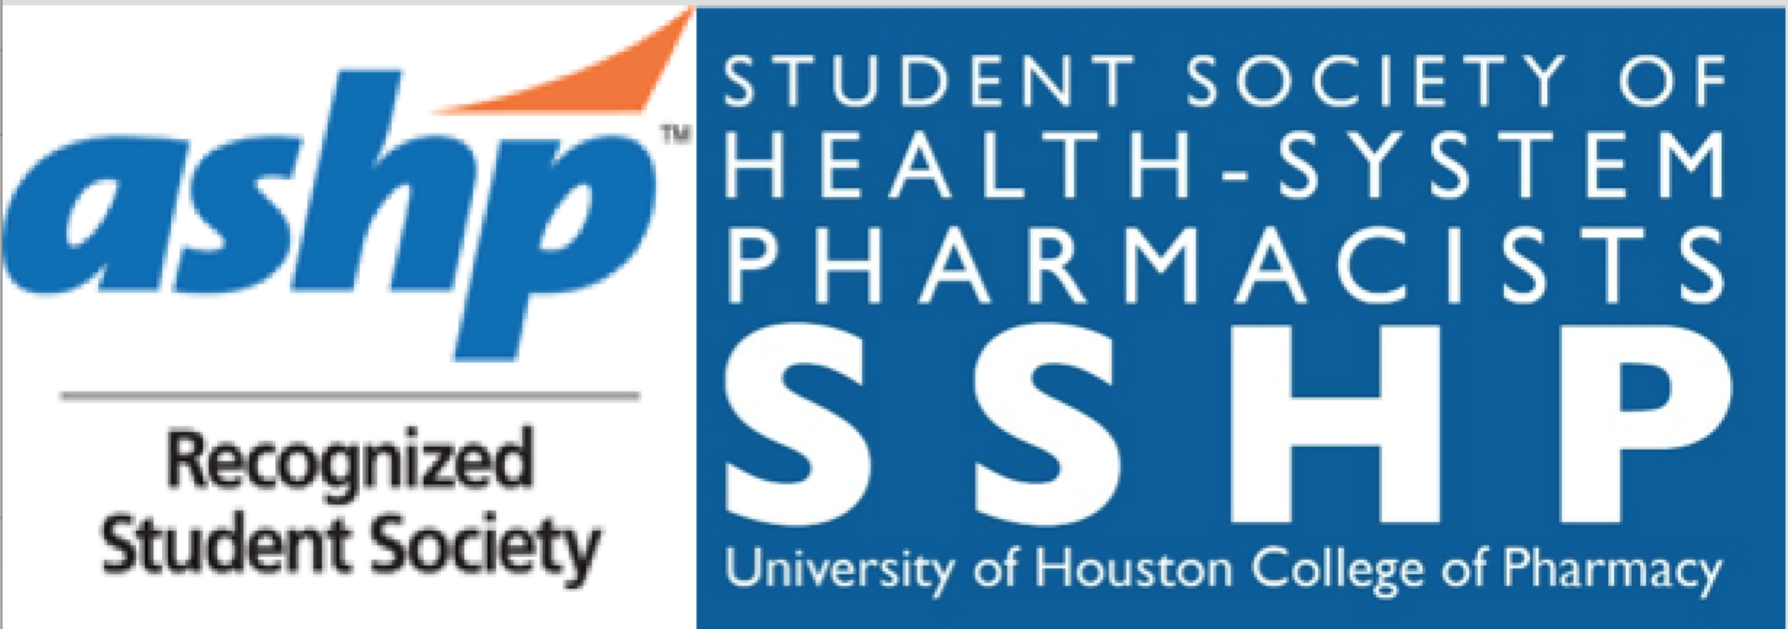
UH SSHP
Meeting Agenda
Monday, 9/18/17
HBSB2, Room 3082
12:00 – 12:50 PM

www.uhsshp.org www.gcshptx.org www.tshp.org www.ashp.org

- Chapter Business
  - ASHP Website Member Benefits: http://www.ashp.org/menu/MemberCenter/Benefits.aspx
  - ASHP Student Site: http://www.ashp.org/students

- Welcome Our Advisors: Dr. Pitman and Dr. Wanat

- SSHP’s Major Fall Clinical Extravaganzas: SAVE THE DATES!
  - Clinical Skills Competition: The Clinical Skills Competition is a great opportunity to practice your clinical skills through case studies. The competition is open to P1-P4 students, and grouped into two categories: P1/P2 & P3/P4. For Part 1, you will compete with an “open-book” in teams of two!
    - Round 1 (written portion, 2 hrs):
      - Friday, Sept 22nd
        - Session 1: 7:30 AM – 9:30 AM
- For all P4’s & P1, P2, P3 teams who have skills lab during the 10 AM-12 PM session
        - Session 2: 10:00 AM – 12:00 PM
- For all P1, P2, P3 teams
    - Round 2 (top selected teams only, oral portion):
      - Saturday, Sept 23rd
        - Starting at 10 AM, specific time & location will be provided in an email
    - Don’t worry if you don’t have a partner—the sign up sheet has a place to check that you don’t have a partner and we will do our best to match you with someone!
    - Winners of the CSC competition from both the P1/P2 and P3/P4 divisions will each receive a cash prize! The P3/P4 1st place team will represent UH at the Clinical Skills Competition at ASHP Midyear in Orlando, Florida. Each member of the overall 1st place (P3/P4) team will receive:
      - Complimentary ASHP Midyear Student Registration ($300 value)
      - Additional $250 reimbursement of their travel expenses
        - The winning team must be a member of SSHP to compete at ASHP Midyear and/or receive the prizes
      - Each winner of P1/P2 category will receive a $50 cash prize and certificate
      - Both winning teams will be announced at the Residency Workshop on October 2nd
    - CSC Training Session:
      - Thank you to those who attended!

  - UH SSHP Residency Workshop - Part 1 of the Residency Preparation Series
    - Come discover what residency is all about and what you need to know to prepare now!
    - Monday, October 2nd (6:00-8:30pm) at Rockwell Pavilion (2nd floor of MD Anderson Library on UH Main Campus) with optional dinner. **Be sure to RSVP for dinner if you would like to join us for supper that evening**
    - Free for SSHP members! Charge of $10 for non-members.
    - Three great presentations:
      - “How to Find your ‘Match’: A Guide to Clinical Pharmacy Residencies”
      - “A Day in the Life: What’s Residency Really Like?”
      - “The Perfect Residency Candidate: Ways to Get the Edge”
  - Work Life Integration: Conversations that Matter – GCSHP event organized by the Leaders of Tomorrow committee
    - Panel of pharmacists will give advice and answer questions based on their experiences
    - Roundtable discussions about gender disparities, work life strategies, and how to “focus on you”
    - Thursday, October 5th at 6:00 pm
- TIRR Research Building
        - 1333 Moursund St., Houston, TX 77030
        - 2nd floor conference room (Room 217)
- RSVP link: https://www.evite.com/event/00B7GXP3M4OEBUAJUEPHRKAD7D3YJQ/rsvp?utm_campaign=send_sharable_link&utm_medium=sharable_invite&utm_source=NA

- P1 Leadership Opportunities:
  - P1 Liaison Elections TODAY!
  - Antibiotics Awareness Junior Chair & Medication Safety Junior Chair: P1 students are encouraged to apply –we’d love to have you on our team! Applications are due by Wednesday, Sept. 20th at 5pm. These positions are exclusively for P1 students. Each position is a 2-year commitment where the Jr. chair will become the Sr. chair their P2 year. The elected P1 Antibiotic Awareness and Medication Safety Junior Chairs will work exclusively with their respective Sr. chair officers. We are looking for members who can bring new ideas to expand and develop the role of these positions and who are enthusiastic about SSHP!

- Service Corner:
  - White Coat Fittings – Friday, Sept. 29th at HBSB2 (main campus). This will be the first UHCOP Class of 2022 interview for the year and we need a few SSHP volunteers to help conduct white coat fittings for prospective students! A sign-up link will be sent in a future email – stay tuned for information.

  - SAVE THE DATES!
    - H.O.M.E.S. Clinic (all spots reserved for SSHP members!) – Sunday, October 8th
    - National Health-System Pharmacy Week – Oct. 15th – 21st
      - Check our website and Facebook page that week for health-system pharmacy history and a daily questionnaire from current health-system pharmacists!
    - American Pharmacists Month Extravaganza – Oct. 19th
- Education tabling event organized by APhA in collaboration with other organizations
- We will be educating about our Antibiotic Awareness and Medication Safety initiatives!
    - Be on the lookout for more information about upcoming health fairs!

- Membership & Meetings:
  - Join SSHP – Online Application! Go to www.tshp.org, select the membership tab and choose Join/Renew. Complete the online form and pay dues with credit/debit card. ($45 for local SSHP, GCSHP, TSHP membership or $95 to include national ASHP membership)
    - Renewing members: Make sure to update your contact information on your TSHP website membership profile page to ensure quick membership turnaround!
    - Deadline: Friday, Sept. 30th to be on our RSVP lists for future meetings & events. Sign up today to ensure free access to the Residency Workshop!
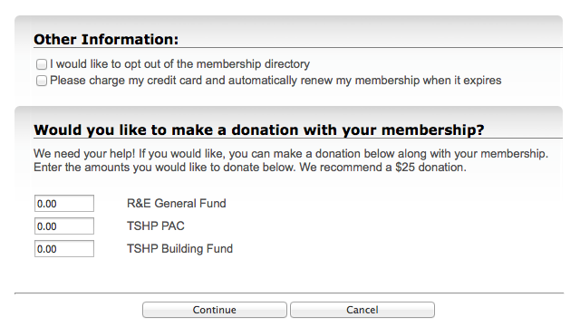
    - When joining/renewing: Please make sure you zero out the donation boxes if you do not plan on/want to make a donation!

  - SSHP T-shirts & Other Swag!
    - Vintage style SSHP shirts - $2
    - ASHP Lapel Pins - $2
    - New SSHP shirts - $9 for short sleeve and $13 for long sleeve
- Our fundraising chairs, Olivia and Sara, will be selling these items at every main campus meeting if you’re interested in purchasing them!
  - Next Main Campus Meeting: Monday, October 9th at 12pm
  - Journal Club: Date TBD! Be on the lookout for more information soon!

- Member Benefits Galore….
  - TSHP Mentor Program: Texas Society of Health System Pharmacy wants to match you up with a pharmacy mentor in an area you’re interested in! P2’s – P4’s apply today at http://www.tshp.org/mentor-program.html
  - Midyear Meeting – Registration and Hotel
The ASHP Midyear Clinical Meeting will be held from December 3-7 in Orlando, FL. There is a wealth of student programming ranging from education sessions to the Residency Showcase. Please visit https://midyear17.ashp.org/Register?ssopc=1. Budget-conscious students are encouraged to book their hotels now using the ASHP Student Room Block. The student block deadline is November 3rd at 7PM, but hotel spots are filling up fast! Want to sign-up or get more information? Visit: https://midyear17.ashp.org/Hotel-and-Travel/Hotel-Reservations-for-Attendees.
  - Midyear Poster Presentations – Deadline to apply: October 1st at 11:59 PM
Why should you present a poster? Poster sessions encourage registrants to informally discuss current projects in pharmacy practice with colleagues. It’s a GREAT opportunity to further your knowledge & facilitate networking! The ASHP Midyear Student Poster Submission site is now open at:
- https://www.ashp.org/meetings-and-events/get-involved-in-a-meeting/midyear-clinical-meeting-and-exhibition/mcm17-poster-information
If you would like to know more about the submission process for presenting a poster, take a look at the Submission Rules & Format Guidelines handbook for Student Posters at:
- https://www.ashp.org/-/media/assets/meetings-events/docs/MCM17-Student-Poster-Guidelines.ashx?la=en&hash=5219104EE66FA57C025A9B13B17E5D488BAEEE4B

Student Society of Health-System Pharmacists
2017-18 Officers

Name | Position | Email Address | Phone # | Yr
Sarah Theriault | President | sgtheriault@uh.edu | 972-302-1686 | P3
Niha Zafar | President-Elect | nzafar@uh.edu | 409-383-3526 | P2
Manal El-Khalil | Immediate Past President | mmelkhal@uh.edu | 832-472-2003 | P4
Julia Roh | VP of Communications | ydroh@uh.edu | 713-894-2120 | P3
Ibrahim Chowdhury | VP of Programming | iachowdhury2@uh.edu | 512-363-9122 | P3
Catherine Nguyen | Secretary | cvnguyen12@uh.edu | 281-857-7746 | P2
Nhi Nguyen | Treasurer | nnnguyen15@uh.edu | 281-935-1376 | P2
Kristi Vo | Historian | kpvo@uh.edu | 713-992-7589 | P2
Grace John | Convention Co-Chair | gnjohn@uh.edu | 832-790-3886 | P2
Tailynn Dinh | Convention Co-Chair | ttdinh8@uh.edu | 832-607-3817 | P2
Aimen Naveed | Orientation Co-Chair | anaveed2@uh.edu | 469-762-9226 | P2
Aminat Tijani | Orientation Co-Chair | Atijani@uh.edu | 6823651540 | P2
Alicia Brazelton | Service Co-Chair | akbrazelton@uh.edu | 832-758-1478 | P2
Jaimy James | Service Co-Chair | jkjames@uh.edu | 972-302-3002 | P2
Olivia Kreidler | Fundraising Co-Chair | omkreidler@uh.edu | 512-586-1569 | P2
Sara Osman | Fundraising Co-Chair | shosman@uh.edu | 404-563-6316 | P2
Dima Basatneh | Professional Development Co-Chair | dimabasatneh@gmail.com | 469-463-2548 | P2
Truong Do | Professional Development Co-Chair | tndo8@uh.edu | 281-624-9368 | P2
- | P1 Liaison | - | - | P1
- | P1 Liaison | - | - | P1
Lauren Le | Medication Safety Senior Chair | ltle@uh.edu | 281-793-5052 | P2
- | Medication Safety Junior Chair | - | - | P1
Catherine Nguyen | Antibiotic Awareness Senior Chair | cvnguyen12@uh.edu | 281-857-7746 | P2
- | Antibiotic Awareness Junior Chair | - | - | P1
Dr. Matthew Wanat | Faculty Advisor | mawanat@central.uh.edu | --- | -
Dr. Paige Pitman | Faculty Advisor | peliza@central.uh.edu | --- | -

