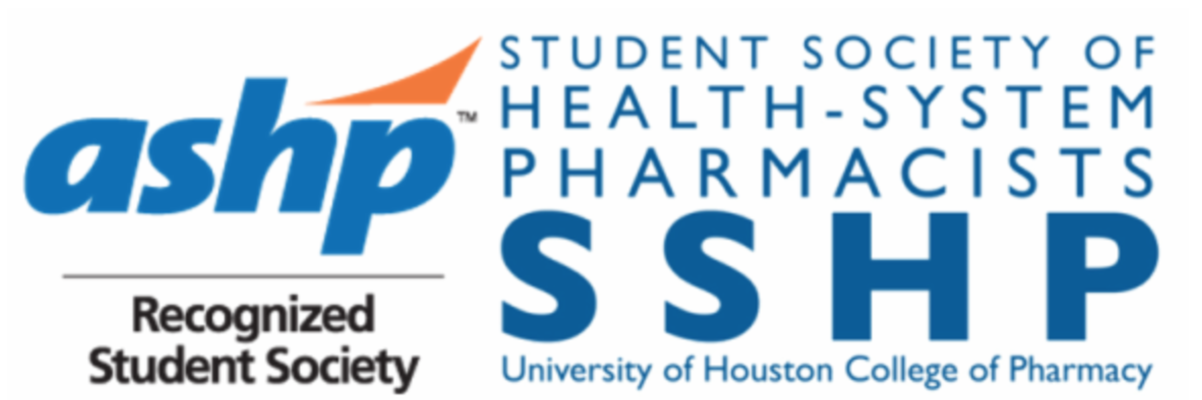
UH SSHP Meeting Agenda
Wednesday, February 28, 2018
12:00 – 12:50 PM

- Chapter business
  - General Meetings this semester - Mark your calendars!
    - Monday, April 2nd: Officer Elections!
    - Tuesday, April 24th
  - EXECUTIVE OFFICER ELECTIONS will be held on April 2! Talk to a current officer if you’re interested in running to get a better idea of the responsibilities of the position!
- Candidates do not have to be a current SSHP member to run
- Candidates may run for a maximum of TWO positions
- If you intend to run for an executive officer position, please fill out this form by March 29th at 11:59 PM: https://docs.google.com/forms/d/e/1FAIpQLSdNEbuEd2-ZutzphU_GZDKFJt4Y6cwyiJ0_5cCGFP-NgpEKEg/viewform
  - CHAIR OFFICER INTERVIEWS will be held during the week of April 16-20! Talk to a current officer if you’re interested in running to get a better idea of the responsibilities of the position!
- Candidates do not have to be a current SSHP member to apply
- Candidates may apply for a maximum of TWO positions
- If you intend to apply for a chair officer position, please fill out this form by April 12th at 11:59 PM: https://docs.google.com/forms/d/e/1FAIpQLScg_caDwLqy-dhEVotDbUXWG_OMaWIPiN9vZMbHziLfFg3wzw/viewform
  - OFFICER POSITION SHOWCASE – Check out this link for a PowerPoint presentation of officer positions and current officer contacts for each position! Several leadership positions are available for P1-P3 students.

- Leadership Development Opportunities
  - Advisory Group Applications (Due May 1st) – ASHP Advisory Groups for the Pharmacy Student Forum and Pharmacy Practice Sections are a great way for emerging leaders in the profession to get their foot in the door at the national level. To be eligible the student must be an ASHP member in good standing. To read more about ASHP’s Advisory Groups, visit this website: https://www.ashp.org/Pharmacy-Student/Pharmacy-Student-Forum/PSF-Advisory-Groups
- Student Forum Advisory Group Applications Due May 1st.
- (Graduating Students) New Practitioners Forum Advisory Group Applications Due May 1st.
- (Graduating Students) Pertinent deadlines for P4s who have applied for residency programs to submit their rank lists for Phases I & II of the Match
- February 12, 2018 you may submit Rank Order Lists for Phase I of the Match.
- March 5, 2018 is the deadline to submit Rank Order Lists for Phase I of the Match.
- March 20, 2018 results of Phase I of the Match will be released.
- March 23, 2018 applicants who did not match during Phase I can apply for Phase II.
- April 4, 2018 final date to register to participate in Phase II of the Match.
- April 5, 2018 deadline to submit Rank Order Lists for Phase II of the Match.
- April 5, 2018 results of Phase II of the Match are released.
- April 13, 2018 applicants who did not match in either phase can apply to remaining programs with available positions.
- April 19, 2018 recommended date for remaining programs to make offers to applicants.

- Upcoming Events
  - Bake Sale – Wednesday, March 7th from 12-1 PM
  - White Coat Fittings – Help interviewing students find the white coat that fits! Shifts are for morning, afternoon or both. Sign up by visiting this link: https://docs.google.com/spreadsheets/d/1v8STSvxEcc8-wKTAbvaql0cbIDlS5Hr7Pwt061g3tWA/edit - gid=0. If you do volunteer for a fitting, make sure to get a copy of the white coat sizes to the interview ambassador captain or me ASAP. Thank you to all the volunteers thus far – you’re the reason this fundraiser is so successful!
  - Are you Smarter than a Pharmacist? – March 29th at 5:30PM. We are partnering with Rho Chi to host this game show themed event! Team sign ups will be sent out soon. Participants will have the opportunity to network with and learn from current pharmacists. Cash prizes will be awarded to the top 3 winning teams!
  - South Shaver Health Fair – April 3rd from 4-5:30 PM. We are partnering with APhA Generation Rx for this health fair! We will be doing health screenings and providing education. Sign up sheet will be sent out soon.
  - Mr. Pharmacy Pageant 2018 – April 12th. Special shout-out to Anthony Tran for accepting his nomination to represent SSHP! Be sure to come out and support him!
  - Teddy Bear Drive - donation box has been set up in the break room! We are accepting new/gently used children’s books, stuffed animals, and toys. All items will be donated to Texas Children’s Hospital at the TMC.
  - HOMES Clinic – May 6th. All spots will be reserved for SSHP members!
  - Items for Sale – Vintage style SSHP shirts - $2; ASHP Lapel Pins – $2; New SSHP shirts – $9 (short sleeve) and $13 (long sleeve). Our fundraising chairs, Sara & Olivia will be selling these items at every meeting if you’re interested in purchasing any of them!

- Member Benefits Galore

- 2018 TSHP Annual Seminar, April 6-8 in The Woodlands, TX: This is a great opportunity to network & learn more about upcoming and current practices in the clinical pharmacy profession! During the seminar, there are multiple opportunities to get involved, including poster presentations, student socials, pharmacy exhibitions, the residency showcase, and Clinical Skills & Disease State Management Competitions!
- Registration (before January 31st): $75
- Registration (February 1st – March 25th): $100
- Onsite Registration: $200
- For info and registration visit: http://tshp.org/registration.html

- Clinical Skills (CSC) and Disease State Management (DSM) Competition at TSHP:
- CSC will be held for teams of two in (P3/P4) and (P1/P2) categories. A team of mixed contestants will be placed in the category of the highest member. Deadline to register is March 15, 2018.
- DSM Competition will be held for individuals competing among all students. Deadline to register is March 15, 2018.
- Registration and information at http://www.tshp.org/clinical-skills--disease-state-management-competition.html
- Prizes: The winner of each competition will receive a certificate, a $75 cash prize, and a complementary registration to the 2018 TSHP Annual Seminar.
- Stay tuned for training sessions to be held later in the semester!

- Does your curriculum vitae (CV) make a good impression? Stay competitive with ASHP’s CV Review Program! (March 1 – March 15, 2017): Would you like a fresh set of eyes to review your CV? ASHP’s CV Review Program is the perfect way to prepare for Midyear, the Match, or graduation. Sign up to participate! Submissions will be accepted from March 1 – March 15. Participants will receive feedback from their viewers by April 30th. MUST BE ACTIVE ASHP MEMBER TO PARTICIPATE. For more information, visit https://www.ashp.org/Pharmacy-Student/Career-Development/CV-Development.

www.uhsshp.org www.gcshp.org www.tshp.org www.ashp.org

Student Society of Health-System Pharmacists
2017-18 Officers

Name | Position | Email Address | Phone # | Year
Sarah Theriault | President | sgtheriault@uh.edu | 972-302-1686 | P3
Niha Zafar | President-Elect | nzafar@uh.edu | 409-383-3526 | P2
Manal El-Khalil | Immediate Past President | mmelkhal@uh.edu | 832-472-2003 | P4
Julia Roh | VP of Communications | ydroh@uh.edu | 713-894-2120 | P3
Ibrahim Chowdhury | VP of Programming | iachowdhury2@uh.edu | 512-363-9122 | P3
Catherine Nguyen | Secretary | cvnguyen12@uh.edu | 281-857-7746 | P2
Nhi Nguyen | Treasurer | nnnguyen15@uh.edu | 281-935-1376 | P2
Kristi Vo | Historian | kpvo@uh.edu | 713-992-7589 | P2
Grace John | Convention Co-Chair | gnjohn@uh.edu | 832-790-3886 | P2
Tailynn Dinh | Convention Co-Chair | ttdinh8@uh.edu | 832-607-3817 | P2
Aimen Naveed | Orientation Co-Chair | anaveed2@uh.edu | 469-762-9226 | P2
Aminat Tijani | Orientation Co-Chair | Atijani@uh.edu | 6823651540 | P2
Alicia Brazelton | Service Co-Chair | akbrazelton@uh.edu | 832-758-1478 | P2
Jaimy James | Service Co-Chair | jkjames@uh.edu | 972-302-3002 | P2
Olivia Kreidler | Fundraising Co-Chair | omkreidler@uh.edu | 512-586-1569 | P2
Sara Osman | Fundraising Co-Chair | shosman@uh.edu | 404-563-6316 | P2
Dima Basatneh | Professional Development Co-Chair | dimabasatneh@gmail.com | 469-463-2548 | P2
Truong Do | Professional Development Co-Chair | tndo8@uh.edu | 281-624-9368 | P2
Alan Luu | P1 Liaison | agluu@uh.edu | 832-385-1037 | P1
Rana Chaaban | P1 Liaison | rchaaban@uh.edu | 972-740-2256 | P1
Lauren Le | Medication Safety Sr. Chair | ltle@uh.edu | 281-793-5052 | P2
Anthony Tran | Medication Safety Jr. Chair | atran54@uh.edu | 443-760-5772 | P1
Catherine Nguyen | Antibiotic Awareness Sr. Chair | cvnguyen12@uh.edu | 281-857-7746 | P2
Evelin Vaquiz | Antibiotic Awareness Jr. Chair | ervaquiz@uh.edu | 832-633-3583 | P1
Dr. Matthew Wanat | Faculty Advisor | mawanat@central.uh.edu | --- | -
Dr. Paige Pitman | Faculty Advisor | peliza@central.uh.edu | --- | -

